### اللهم علمنا ما ينفعنا، وانفعنا بما علمتنا، وزدنا علما "سُبْحَانَكَ لا عِلْمَ لَنَا إِلَّا مَا عَلَّمْتَنَا إِنَّكَ أَنْتَ الْعَلِيمُ الْحَكِيم"

# Band Reject Filter Example with Calculated Values

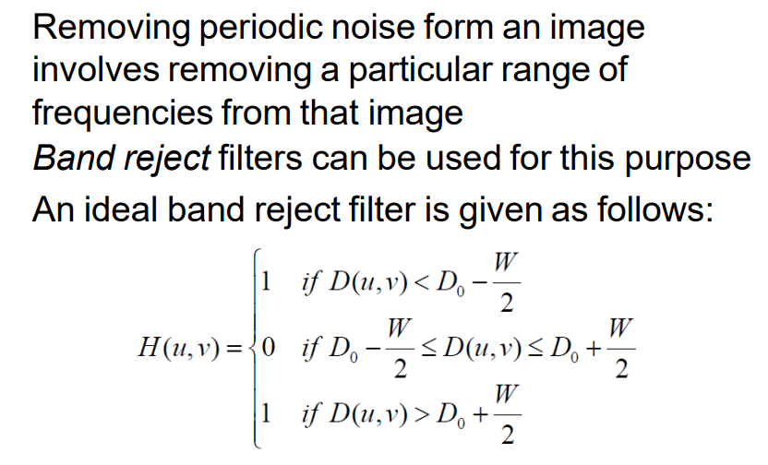Parameters:  
D0 = 50, W = 20, M = 100, N = 100

Lower limit (D0 - W/2) = 40.0

Upper limit (D0 + W/2) = 60.0

Hint: D (u, v) = [(u-M / 2) ^2 + (v - N / 2) ^2] ^1/2

|  |  |  |  |
| --- | --- | --- | --- |
| Point (u, v) | D(u, v) | H(u, v) | Decision |
| (60, 40) | 14.14 | 1 | Pass |
| (70, 50) | 20.00 | 1 | Pass |
| (80, 80) | 42.43 | 0 | Reject |
| (30, 20) | 36.06 | 1 | Pass |
| (90, 90) | 56.57 | 0 | Reject |